



Unified Ecosystem Experience User Guide

December 2019



Real Life

Life Changing

Changing Healthcare

Copyright

NAVVIS Unified Ecosystem Experience (UEE) user guide release 1.00.

Copyright © 2019 NAVVIS & Company, LLC. All rights reserved.

Trademarks

The other product names mentioned may be trademarks of their respective owners.

Disclaimer

Sample names and persons used in this document are purely fictitious and do not refer to real names or persons.

This user's guide has been created with utmost care; nevertheless, it is not guaranteed that this document is error free.

No part of this document may be reproduced or transmitted in any form or by any means, electronic or mechanical, for any purpose, without the express written approval of Navvis & Company.

Table of Contents

1 Preface 5

1.1 About Navvis Coreo Unified Ecosystem Experience 5

1.2 Purpose of this document 5

1.3 Intended audience 5

1.4 Organization of the document 5

1.5 Document Conventions 6

1.6 Browsers Versions for UEE 6

Unified Ecosystem Experience User Function 7

1 User Onboarding 8

1.1 Log into UEE - First Time User 8

1.2 Manage locked NAVVIS – Okta SSO account 14

1.3 Reset a forgotten or expired password 14

2 UEE Screen Layout – Panel View 16

2.1 Toolbar Elements 17

2.2 Panel Elements 18

3 Display Settings for UEE Panels 18

3.1 Set Up Single Panel View 18

3.2 Set Up Two-Panel View 18

3.3 Set Up Three-Panel View 18

3.4 Edit the Toolbar 18

3.4.1 Pin a Coreo Application to the Toolbar 18

3.5 Select a Coreo application to Apply on the Screen Directly 18

4 Panel Formats and Screen Resolutions 18

4.1 Panel Formats in Standard View and Widescreen View 18

4.2 Screen Resolutions for Optimal Display of Pinned Applications 18

Exhibit: UEE Administrative Function 19

1 Coreo View Administrator Tasks 20

1.1 Navvis account activation for the Coreo View administrator user 20

1.2 Manage locked Navvis administrator account 24

1.3 Reset a forgotten or expired administrator password 24

2 Appendices 27

3 Glossary 28

4 Index 29

# Preface

Welcome to the release of the NAVVIS Unified Ecosystem Experience user guide.

## About Navvis Coreo Unified Ecosystem Experience

NAVVIS Coreo View is a software platform which empowers the users to manage the status and the flow of patients through Acute Care (AC), Post-Acute Care (PAC) and home networks.

Coreo View is HIPAA (Health Insurance Portability and Accountability Act) compliant and is available as a SaaS (Software-as-a-Service) cloud solution enabling management of patients with real-time data. Coreo View is part of the Coreo ecosystem which allows cross-continuum care coordination and ensures seamless care transition.

Navvis & Company provides counsel to health systems, hospitals and physician groups on the development of innovative, market-linked strategies to build future-ready health systems, cultivate tomorrow’s leaders and strengthen strategic performance.

## Purpose of this document

This guide is the primary source of information about Navvis Unified Ecosystem Experience. It contains overviews, processes, and procedure to use the Unified Ecosystem Experience application effectively.

## Intended audience

1. The regular users of the Unified Ecosystem Experience application who include the following personnel:

* Clinical staff and hospital administrators
* Employees, consultants, contractors or agents of the clinicians or patients who have been invited by the clinician or patient to access and use the service to participate in the care of the patient.
* Any other person or entity involved in the care of the patient including patient's care providers, patient's insurer or payer, or a social worker, or government agencies.

1. Unified Ecosystem Experience administrator users who are assigned the task of managing the regular users of the Unified Ecosystem Experience application

## Organization of the document

This document contains the following modules:

* Exhibit A: Coreo View User Function
  + Module 1, “User on boarding”
  + Module 2, “Screen layout and navigation”
  + Module 3, “Filters and Themes”
  + Module 4, “Bed view features”
  + Module 5, “Prioritized view features”
  + Module 6, “Goo-map view features”
  + Module 7, “Switching the navigation between views”
  + Module 8, “Patient summary”
  + Module 9, “Search feature”
  + Module 10, “Flagging patient records”
  + Module 11, “General reports”
* Exhibit B: Coreo View Administrative Function
  + Module 1, “Coreo View Administrator Tasks”
  + Module 2, “Settings to manage Coreo View regular users”
  + Module 3, “Automation events”
  + Module 4, “Administrative reports”

## Document Conventions

This document uses the following conventions:

| Convention | Item |
| --- | --- |
| **boldface** font | **Menu** items, **Tab** names, **Text** **box** names, **List** **box** names, **Button** names and **Navigation** paths |
| Text in blue | Hyperlinks |
|  | Note: Notes contain helpful suggestions. A note will inform the reader about any deviation in the sequence of instructions or helps the reader save time in understanding why something is not working. |
|  | Tip: The information will help the user solve a problem faster, or to perform an action in a different way. |
|  | Caution alerts the reader to avoid doing something that could result in loss of data or any other damage. |

## Browsers Versions for UEE

The Unified Ecosystem Experience application is available on desktops, laptops, IOS devices and android tablets.

| Browser | Version |
| --- | --- |
| Google Chrome | 74 |
| MS Internet Explorer | 11 |
| Macbook - Safari | 12.1.1 |
| Samsung Tab – Google Chrome | 7.0.0 |
| IPad IOS - Safari | 12.1 |

Unified Ecosystem Experience User Function

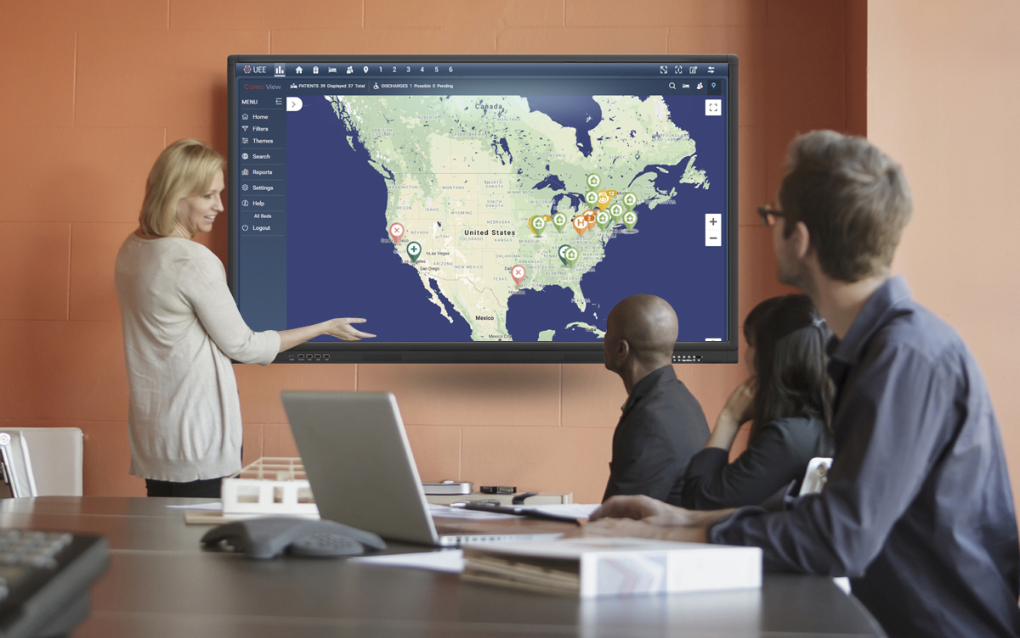

# User Onboarding

A first-time user of Unified Ecosystem Experience (UEE) receives an automated email verification link from the okta system administrator to activate the Okta account. Okta Single Sign-On(SSO) provides a single secure home page to use the UEE application.

## Log into UEE - First Time User

Follow these steps to activate the Okta SSO account to access Unified Ecosystem Experience:

1. Open the email link sent to your email inbox by the Okta administrator.



1. Email Notification
2. Select the ActivateAccLinkGreenBox.png link. The **Create your Navvis account** screen opens.

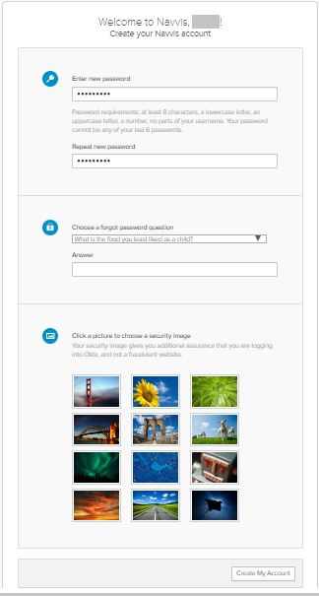

1. Create Your Navvis Account Screen
2. Enter the new password in **Enter new password**. The password must be at least 8 characters long and a maximum of 25 characters.

The password must be a combination of these following characters:

| Description | Characters |
| --- | --- |
| Upper case characters | A – Z |
| Lower case characters | a – z |
| Digits | 0 – 9 |
| Special characters | ~ ! @ # $ % ^ & * _ - + = ` | \ () {} [] : ; " ' < > , . ? / |

1. System Accepted Password Characters
2. Reenter the password in the **Repeat new password** box.
3. The user must add a security question to reset a new password in the scenario where user may forget the password during the future use.
4. Under **Choose a forgot password** question, select the arrow to view the questions.



1. Choose A Forgot Password Question
2. Choose a security question from the list.
3. In the **Answer** box, enter the answer. You must remember this answer because it is used at a later date to reset a forgotten or expired password.
4. Choose a picture as a security image in the **Create your Navvis account** screen and then select **Create My Account**.

|  |  |
| --- | --- |
|  | The security image displays in the NAVVIS Sign In screen on entering the user name. |

1. The **Navvis** landing screen opens.

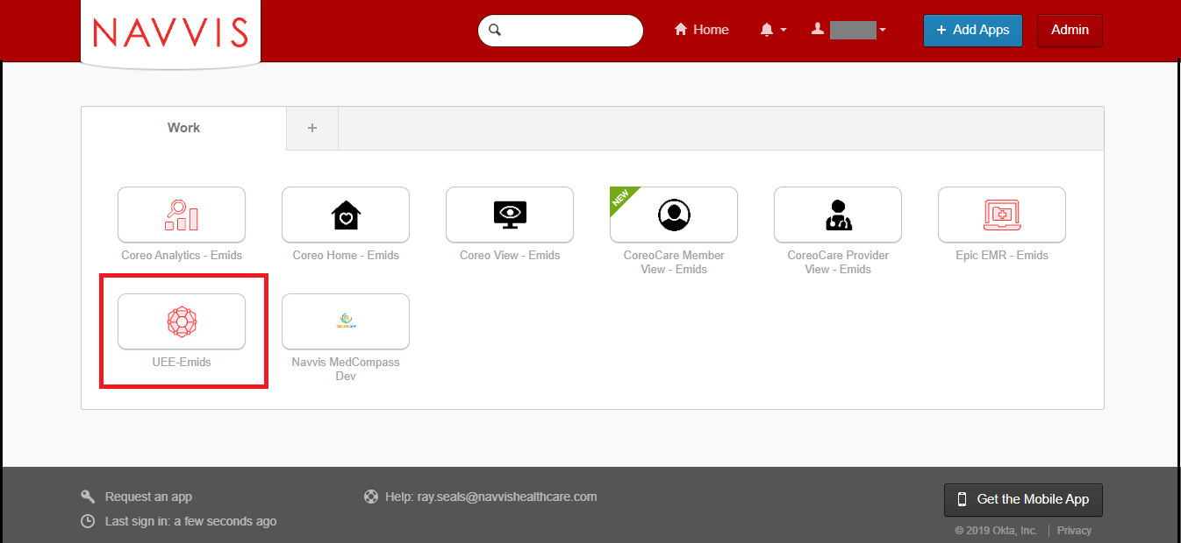

1. NAVVIS Landing Screen
2. Select the **UEE - Emids** button on the landing screen.
3. The **NAVVIS Sign in** screen opens.

|  |  |
| --- | --- |
|  | Once the user accepts EULA and the Navvis – okta SSO account is activated, the new user becomes an existing user.  As an existing user, go to [navvis.oktapreview.com](https://navvis.oktapreview.com/) to open the NAVVIS Sign in screen. |



1. NAVVIS Sign In Screen
2. Enter the user ID in the **Username** box on the.
3. Enter the password in the **Password** box. The password must be at least 8 characters long and a maximum of 25 characters.
4. Select **Sign In**.
5. The EULA screen displays for a first-time user of UEE. A first-time user of UEE is required to accept the EULA (End User License and Business Associate Agreement) before accessing the UEE application.

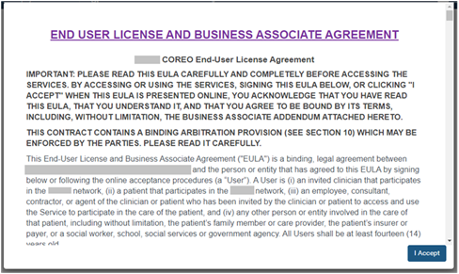

1. EULA PAGE
2. Read the terms and conditions and select the **I Accept** button. Your NAVVIS account is activated successfully and the UEE home page opens.

## Manage locked NAVVIS – Okta SSO account

The Navvis – Okta SSO account locks for the following reasons:

* The user exceeds five failed login attempts within 24 hours. The login attempts fail when the user enters an incorrect password.

The locked account resets after 24 hours and the user can log in to the account after 24 hours without contacting the okta system administrator.

|  |  |
| --- | --- |
|  | To unlock the NAVVIS account immediately after the five failed login attempts, contact the Okta system administrator. |

* The Okta system administrator can lock the NAVVIS – Okta SSO account as per the company lock account policy.

## Reset a forgotten or expired password

The Okta Single Sign-On password policy specifies that the password expires after 60 days, and the user must reset the password periodically.

Also, if the user forgets the password, Navvis – Okta gives the option to reset the password.

Follow these steps to reset the password:

1. Go to [navvis.oktapreview.com](https://navvis.oktapreview.com/) to open the **Navvis Sign in** screen.



1. NAVVIS Sign In Screen - Forgot password? Option
2. Select the **Need help signing in?** drop-down list.
3. Select the **Forgot password?** option to open the **Reset Password** screen.



1. Reset Password Screen
2. Enter the e-mail or the user name in the **Email or Username** box.
3. Select **Reset via E-mail**. The user can reset the password using the verification link sent to the user’s email address.
4. Reset the password with the following considerations:

* The new password cannot be among the previous six passwords.
* The password expires after 60 days and the user must reset the password periodically.
* The user will be locked out of the application after five failed login attempts. The login attempts fail when the user enters an incorrect password. Contact the Okta administrator to reset the password.

On the successful resetting of the password, the new password is reset for the Navvis Okta Single Sign-On account.

# UEE Screen Layout – Panel View

The screen layouts in the UEE application are similar in appearance. However, a few user interface elements differ depending upon the number (one, two or three) of panels that are displayed on the screen and on the user’s role and permissions.

The user can configure a Coreo application to view it in a single panel or configure multiple Coreo applications to view them in multi-panels on their device screen, with each application assigned to a panel.

Each of this configuration that assigns the Coreo applications to their panels and which can be applied to the device screen layout is called a preset.

The single panel configuration is available on standard screens and widescreens, and the multi-panel configurations are available on widescreen only.

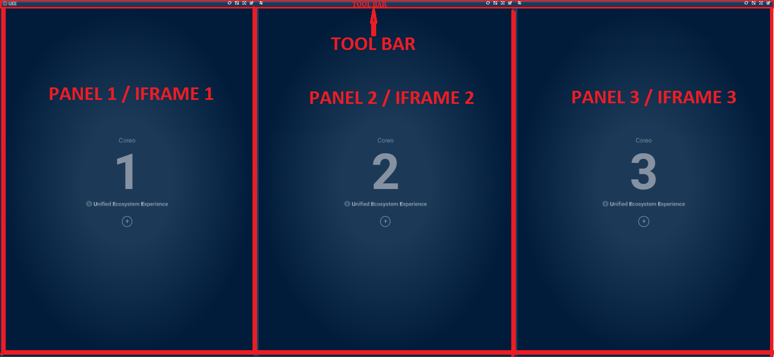

1. UEE Home Page

The UEE home page layout includes the following areas:

* Toolbar: Includes buttons to apply the layout configuration to the panels, to access the display settings for the panel view, and to control the magnification settings of the panel view.
* Panel or Iframe: Each Coreo application can be assigned to a panel and can have a maximum of three panel views.

The user can assign the following Coreo applications to a panel:

* + Coreo Analytics
  + Coreo Home
  + Coreo Care – Team View
  + Coreo Care – Provider View
  + Coreo View – Bed View
  + Coreo View – Geomap View
  + Coreo View – Prioritized View
  + Coreo Healthwise
  + Navvis Analytics
  + Epic EMR
  + Coreo Care- Member View

Toolbar Elements

Refer to the following table to view details about the buttons included in the tool bar.

| Icon | Element name | Description |
| --- | --- | --- |
|  | **UEE** Logo | The UEE logo |
|  | **Refresh** button | Use this to refresh the Coreo application displayed in that panel. |
|  | **Maximize Display** toggle button | Use this button to enlarge the panel layout view to fit the entire screen of the device. Select the same button or select **Esc** on the keyboardto exit the full screen. |
|  | **UEE Help** button | Use this button to open the UEE user help document. |
|  | **Display Settings** button | Use this button to open the **Display Settings** pop-up window. In the pop-up window, you can create, modify, or delete presets. You can also pin an application or a preset on the tool bar using this window. |
|  | **Swap** button | Use this to inter change the applications between two panels. |
|  |  |  |
|  |  |  |
|  |  |  |
|  |  |  |
|  |  |  |
|  |  |  |
|  |  |  |
|  |  |  |
|  |  |  |
|  |  |  |
|  |  |  |

1. Toolbar Elements

## Panel Elements

# Display Settings for UEE Panels

## Set Up Single Panel View

## Set Up Two-Panel View

## Set Up Three-Panel View

## Edit the Toolbar

Pin a Coreo Application to the Toolbar

## Select a Coreo application to Apply on the Screen Directly

# Panel Formats and Screen Resolutions

## Panel Formats in Standard View and Widescreen View

## Screen Resolutions for Optimal Display of Pinned Applications

Exhibit: UEE Administrative Function



# Coreo View Administrator Tasks

The okta Single Sign-On system administrator has the super user privileges and creates the Coreo View administrator role. okta provides a single secure home page to use the Coreo View application.

The Coreo View administrator manages the users and all the related administrative functions, which include the following:

* Manages the regular users of the Coreo View application.
* Assigns roles and permissions for the regular users from the user groups.

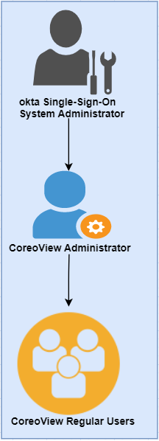

1. Administrator Role Hirearchy

## Navvis account activation for the Coreo View administrator user

The okta system administrator will register a user in okta and assigns the administrative privilege and access to the Coreo View application. The Coreo View administrator user manages the Coreo View regular users.

The okta system administrator sends an email notification to the Coreo View administrator user to initiate the account activation process.

|  |  |
| --- | --- |
| Note icon.png | okta sytem administrator can create multiple Navvis administrator accounts for the Coreo View application. However, the Coreo View administrator can only assign the administrator role to another user in Coreo view. |

Follow these steps to activate the Okta account:

1. Open the email link sent to your email inbox by the Okta administrator.



1. Email Notification

2. Select the ActivateAccLinkGreenBox.png link. The **Create your Navvis account** screen opens.

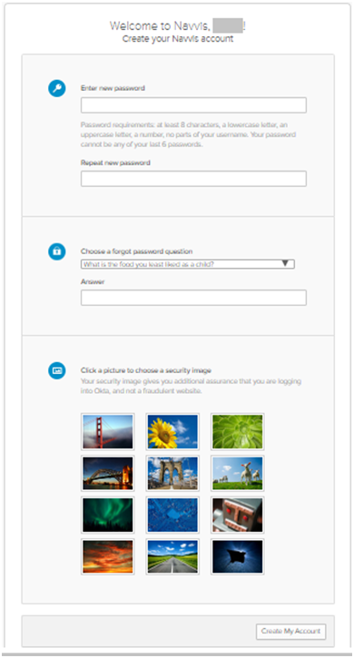

1. Create Your Navvis Account Screen
2. Enter the new password in **Enter new password**. The password must be at least 8 characters long and a maximum of 25 characters.

The password must be a combination of these following characters:

| Description | Characters |
| --- | --- |
| Upper case characters | A – Z |
| Lower case characters | a – z |
| Digits | 0 – 9 |
| Special characters | ~ ! @ # $ % ^ & * _ - + = ` | \ () {} [] : ; " ' < > , . ? / |

1. System Accepted Password Characters
2. Reenter the password in the **Repeat new password** box.

The user must add a security question to reset a new password in the event of the user forgetting the password during the future use.

1. Under **Choose a forgot password** question, select the arrow to view the questions.

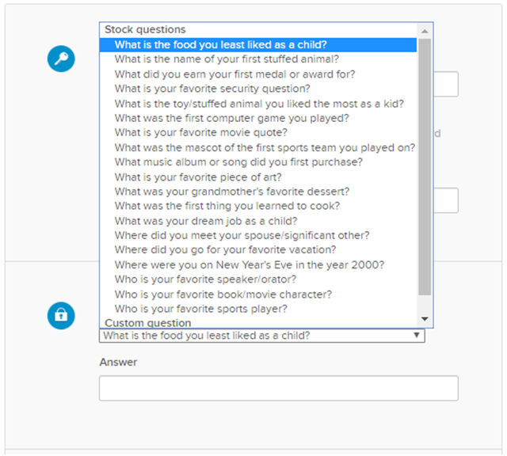

1. Choose A Forgot Password Question
2. Choose a security question from the list.
3. In the **Answer** box, enter the answer. You must remember this answer because it is used at a later date to reset a forgotten or expired password.
4. Choose a picture as a security image in the **Create your Navvis account** screen and then select **Create My Account**.

|  |  |
| --- | --- |
| Note icon.png | The security image displays in the NAVVIS Sign In screen when the user logs in. |

1. The **Navvis** landing screen opens.

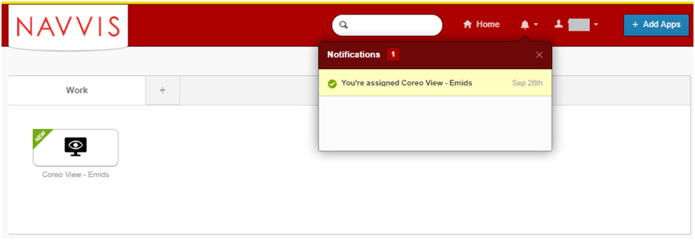

1. NAVVIS Landing Screen
2. Select the **Coreo View - Emids** icon on the landing screen.
3. The **NAVVIS Sign in** screen opens.

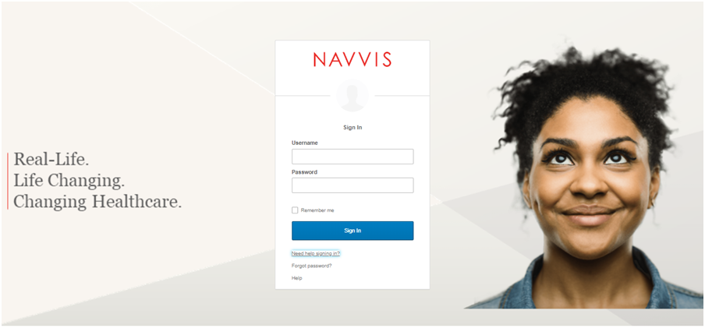

1. NAVVIS Sign In Screen
2. Enter the user ID in the **Username** box on the.
3. Enter the password in the **Password** box. The password must be at least 8 characters long and a maximum of 25 characters.
4. Select **Sign In**.
5. The EULA screen displays for a first-time user of Coreo View. A first-time user of Coreo View is required to accept the EULA (End User License and Business Associate Agreement) before accessing the Coreo View application.

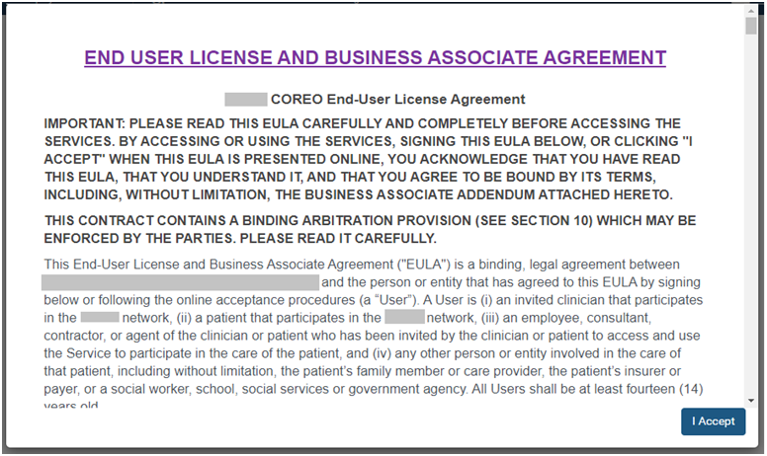

1. EULA PAGE
2. Read the terms and conditions and select the **I Accept** button. Your Navvis account is activated successfully and the NAVVIS home page opens.

## Manage locked Navvis administrator account

The Navvis account locks for the following reasons:

* The user exceeds five failed login attempts within 24 hours. The login attempts fail when the user enters an incorrect password.

To unlock the Navvis account immediately after the five failed login attempts, contact the okta system administrator.

|  |  |
| --- | --- |
| Note icon.png | The locked account resets after 24 hours and the user can log in to the account after 24 hours. |

* The okta system administrator can lock the Navvis account as per the company lock account policy.

## Reset a forgotten or expired administrator password

The okta Single Sign-On password policy specifies that the password expires after 60 days, and the user must reset the password periodically.

Also, if the user forgets the password, Coreo View gives the option to reset the password.

Follow these steps to reset the password:

1. Go to [navvis.oktapreview.com](https://navvis.oktapreview.com/) to open the **Navvis Sign in** screen.

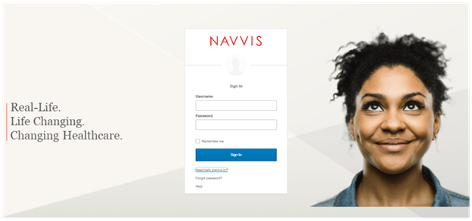

1. NAVVIS Sign In Screen - Forgot password? Option
2. Select the **Need help signing in?** drop-down list.
3. Select the **Forgot password?** option to open the **Reset Password** screen.

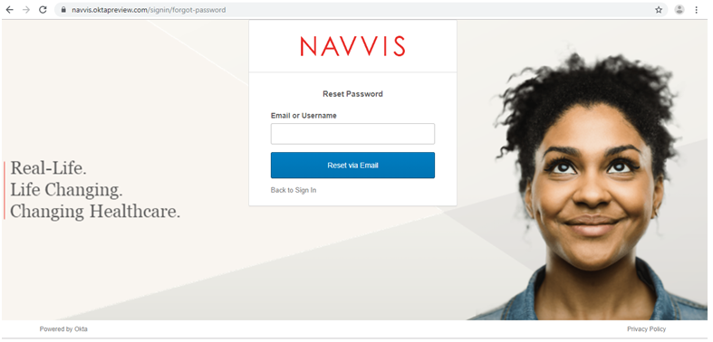

1. Reset Password Screen
2. Enter the e-mail or the user name in the **Email or Username** box.
3. Select **Reset via E-mail**. The user can reset the password using the verification link sent to the user’s email address.
4. Reset the password with the following considerations:

* The new password cannot be among the previous six passwords.
* The password expires after 60 days and the user must reset the password periodically.
* The user will be locked out of the application after five failed login attempts. The login attempts fail when the user enters an incorrect password. Contact the okta administrator to reset the password.

On the successful resetting of the password, the new password is reset for the Navvis account.

Appendices

Credits

[www.bloomberg.com/profile/company/3553499Z:US](http://www.bloomberg.com/profile/company/3553499Z:US)

[www.navvishealthcare.com/](http://www.navvishealthcare.com/)

[www.linkedin.com/company/navvishealthcare](http://www.linkedin.com/company/navvishealthcare)

[www.pitchbook.com/profiles/company/88126-75](http://www.pitchbook.com/profiles/company/88126-75)

[www.crunchbase.com/organization/navvis-company](http://www.crunchbase.com/organization/navvis-company)

[www.healthcareitnews.com/blog/defining-population-health](http://www.healthcareitnews.com/blog/defining-population-health)

Glossary

[Glossary term – Description]

[Glossary term – Description]

[Glossary term – Description]

[Glossary term – Description]

[Glossary term – Description]

……………………..

Index

[Depending on the size or complexity of the final document, insert an index to assist the user in locating specific information. Index entries correspond to tags or categories, and are useful in navigating long books.]

[Index term – *page number*]

[Index term – *page number*]

[Index term – *page number*]

[Index term – *page number*]

[Index term – *page number*]